STUDENT VISA-STANDARD OPERATING PROCEDURE

Document Control
Document No. | SOP-SV-001
Version | 1.0
Department | Migration Services
Effective Date | ________________
Approved By | ________________

1. Purpose
This SOP establishes a consistent, efficient and compliant process for handling Student Visa (Subclass 500) applications from initial enquiry through to visa outcome. It standardizes workflows, improves service quality, ensures legislative compliance and maintains complete client records.

2. Scope
This procedure applies to all Student Visa (Subclass 500) applications handled by Yale Migration.
The SOP covers:
- Initial enquiries
- Eligibility assessment
- Client engagement
- School enrolment
- Document collection
- Visa preparation
- Visa lodgement
- Post-lodgment monitoring
- Visa outcome management

3. Roles and Responsibilities

3.1 Registered Migration Agent
- Assess eligibility and migration risks.
- Provide migration advice and conduct consultations.
- Approve enrolment strategy where required.
- Review all visa documents and Genuine Student Statement.
- Conduct final quality assurance before lodgment.
- Lodge applications through Immi Account.
- Monitor applications and respond to Department requests.

3.2 Consultant
- Respond to enquiries and collect preliminary information.
- Prepare quotations, Service Agreement and checklists.
- Coordinate school enrolment.
- Collect, organize and save client documents.
- Prepare visa draft and supporting documents.
- Coordinate client review.
- Monitor application progress and communicate updates.
- Prepare invoices and maintain records.

4. Tools and Systems
- ImmiAccount
- Client Management System
- Client Engagement Log
- Secure Cloud Document Storage
- Standard Checklists and Templates
- Email and Microsoft Office / Google Workspace

5. Document Management

Every client must be registered in the Client Engagement Log to generate a Unique Client Code

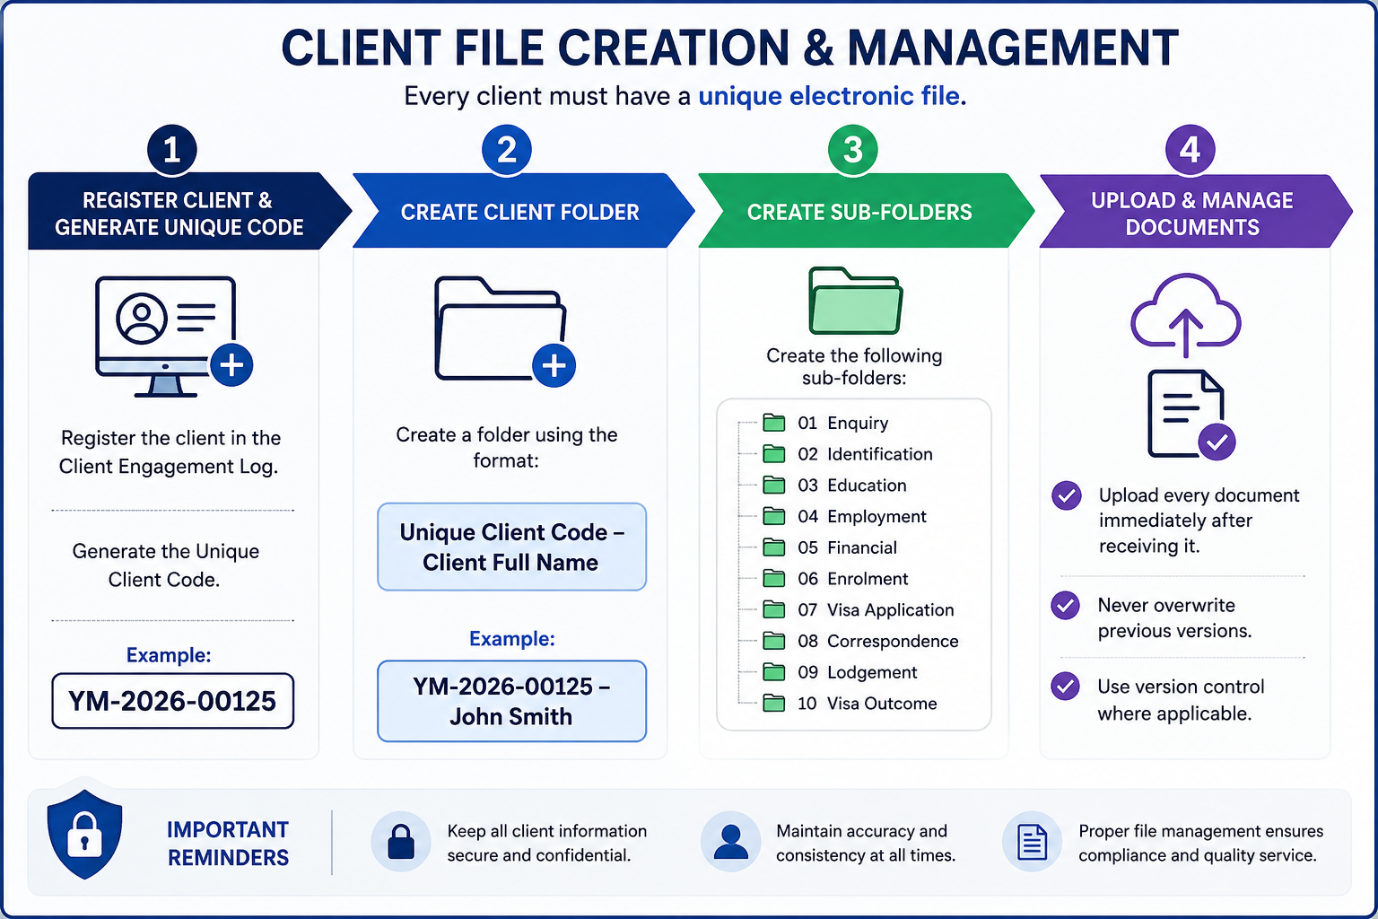
Step | Process | Procedure
1 | Register Client | Register the client in the Client Engagement Log and generate a Unique Client Code.  Example: YM-2026-00125
2 | Create Client Folder | Create a client folder using the following naming convention:  Unique Client Code – Client Full Name  Example: YM-2026-00125 – John Smith
3 | Create Sub-Folders | Create the following folders within the client's main folder:  01. Enquiry  02. Identification  03. Education  04. Employment  05. Financial  06. Enrolment  07. Visa Application  08. Correspondence  09. Lodgement  10. Visa Outcome
4 | Upload & Maintain Documents | Upload all client documents immediately upon receipt.  • Do not overwrite previous versions.  • Apply version control where necessary.  • Ensure all documents are saved in the correct sub-folder.

6. Student Visa Application Procedure
Step | Process | Responsible | Required Action
1 | Receive enquiry | Consultant | Respond to enquiry and provide general information.
2 | Request documents | Consultant | Obtain enquiry form, resume, passport and current visa if applicable.
3 | Eligibility assessment | Migration Agent | Assess eligibility and migration risks.
4 | Consultation | Migration Agent / Consultant | Discuss requirements, courses, fees, pathways and visa conditions.
5 | Client engagement | Consultant | Register client, generate code, create folder, send quotation, Service Agreement and checklist.
6 | Agreement | Consultant | Receive signed Service Agreement and initial payment.
7 | Document collection | Consultant | Collect, review and upload documents.
8 | Enrolment | Consultant | Prepare and submit enrolment documents.
9 | Offer Letter | Consultant | Review and send to client for signature and payment.
10 | CoE | Consultant | Obtain Confirmation of Enrolment.
11 | Visa preparation | Consultant | Prepare visa application and supporting documents.
12 | Internal review | Migration Agent | Conduct final review and quality check.
13 | Client review | Consultant | Obtain written confirmation of application details.
14 | Visa lodgement | Migration Agent | Lodge application via ImmiAccount.
15 | Update records | Consultant | Update lodgement register and save confirmations.
16 | Post-lodgement | Consultant | Send acknowledgement, BVA (if applicable), HAP ID and medical instructions.
17 | Monitoring | Consultant / Migration Agent | Monitor progress and respond to requests.
18 | Outcome | Consultant / Migration Agent | Advise client of visa outcome and next steps.
19 | Close file | Consultant | Update records and archive the file.

7. Quality Control Checklist
The Registered Migration Agent must complete the following quality assurance checks before lodging any Student Visa application. No application is to be lodged until all applicable items have been reviewed and confirmed.
Quality Check | Completed (✓)
Client identity has been verified using a valid passport or government-issued identification. | ☐
Passport is valid for the intended visa application period. | ☐
Confirmation of Enrolment (CoE) has been received and verified. | ☐
Overseas Student Health Cover (OSHC) is valid for the required visa duration. | ☐
Genuine Student Statement has been reviewed and approved by the Registered Migration Agent. | ☐
Financial capacity documents have been assessed and meet the Department's requirements. | ☐
English language requirements have been met (where applicable). | ☐
All supporting documents have been checked for completeness, accuracy and consistency. | ☐
Client's personal information is consistent across all documents and forms. | ☐
All required forms and declarations have been completed and signed. | ☐
Client has reviewed and approved the final visa application before lodgment. | ☐
Visa Application Charge (VAC), professional fees and any additional charges have been confirmed with the client. | ☐
All documents have been correctly named, organized and saved in the client's electronic folder. | ☐
The Migration Agent has completed the final compliance review and approved the application for lodgment. | ☐
Lodgment confirmation, Transaction Reference Number (TRN) and supporting records have been saved after submission. | ☐
Important: Any discrepancies or missing information identified during the quality review must be resolved before the application is lodged.

8. Compliance and Disclosure
Yale Migration is committed to maintaining the highest standards of professionalism, ethical conduct and compliance with Australian migration legislation.
All staff involved in Student Visa applications must comply with the following requirements:

Legislative Compliance
- Comply with all applicable Australian migration legislation, regulations and policy requirements.
- Follow all requirements of the Department of Home Affairs when preparing and lodging visa applications.
- Ensure that all information provided in a visa application is accurate, truthful and supported by appropriate evidence.

Professional Responsibilities
- Only a Registered Migration Agent may provide migration advice or make legal representations regarding visa matters.
- Consultants and administrative staff must not provide migration advice unless authorised to do so.
- Any complex migration issues must be referred to the Registered Migration Agent.

Client Confidentiality
- Protect all client information in accordance with Australian privacy requirements and the agency's privacy policy.
- Client information must only be accessed by authorized staff for legitimate business purposes.
- Client documents must be stored securely within the agency's approved document management system.

Accuracy and Record Management
- Maintain complete, accurate and up-to-date client records always.
- Record all client communications, advice provided, and documents received or submitted.
- Ensure all electronic files follow the agency's document naming and filing procedures.

Fee Disclosure
Before commencing any work, the client must receive clear written information regarding:
- Professional service fees.
- Government Visa Application Charges (VAC).
- Overseas Student Health Cover (OSHC) costs.
- School tuition fees.
- Any additional third-party charges that may apply.

Client Acknowledgement
Before visa lodgment, the client must acknowledge that:
- All information provided is true, complete and accurate.
- They have reviewed and approved the final visa application.
- They understand their obligations as a Student Visa holder.
- They understand that providing false or misleading information may result in visa refusal or cancellation.

Visa Outcome Disclaimer
Yale Migration will prepare and manage every application with due skill, care and diligence. However, the approval or refusal of any visa application is solely at the discretion of the Department of Home Affairs.
Neither Yale Migration nor the Registered Migration Agent can guarantee the grant of a visa, as each application is assessed on its individual merits and in accordance with Australian migration legislation and policy.

